Bullying:
The Social Destruction of Self

--Laura Martocci, Ph.D.
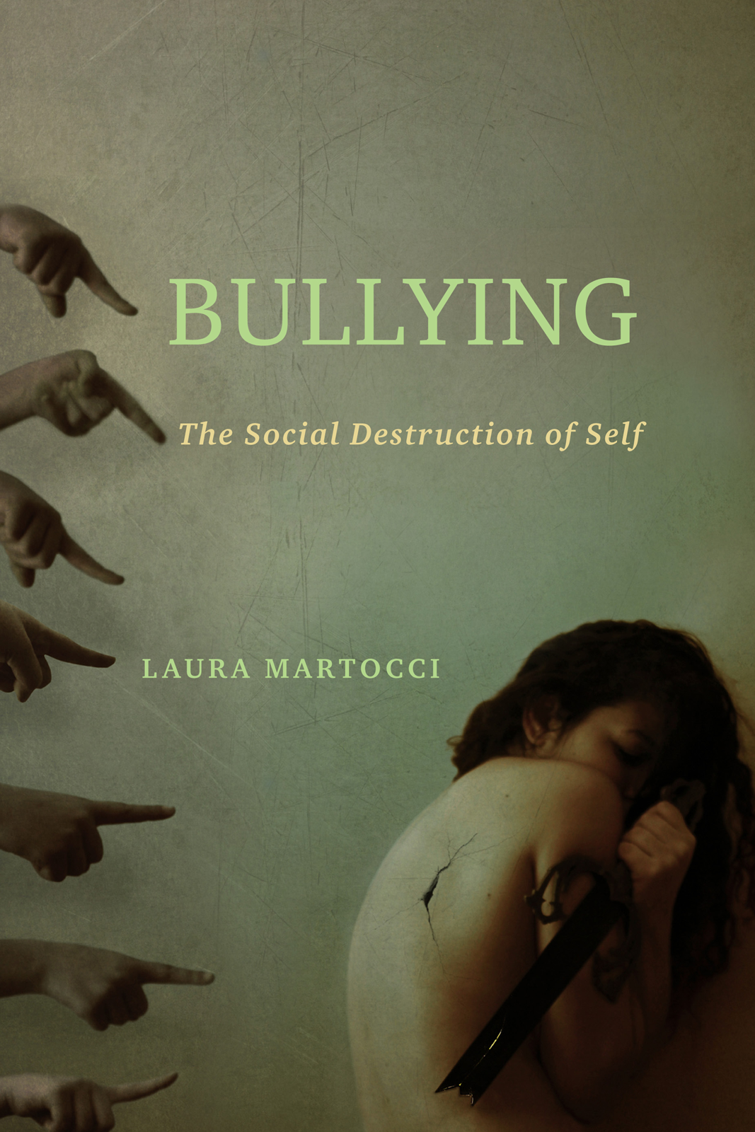

“ A very useful and up-to-date discussion of the social-emotional origins of bullying."
—Thomas Scheff, Professor Emeritus
University of California, Santa Barbara

In her forceful social history, Bullying, Laura Martocci explores the “bully culture” that has claimed national attention since the late 1990s.
Moving beyond the identification of aggressive behaviors to an analysis of how and why we have arrived at a culture that thrives on humiliation, she critiques the social forces that gave rise to, and help maintain, bullying. Martocci’s analysis of gossip, laughter, stereotyping, and competition—dynamics that foment bullying and prompt responses of shame, violence, and depression—is positioned within a larger social narrative: the means by which we negotiate damaged social bonds and the role that bystanders play in the possibility of atonement, forgiveness, and redemption.
Martocci’s fresh perspective on bullying positions shame as pivotal. She urges us to acknowledge the pain and confusion caused by social disgrace; to understand its social, psychological, and neurological nature; and to address it through narratives of loss, grief, and redemption—cultural supports that are already in place.

Reviews
"Martocci’s book offers a new and exciting interdisciplinary and sociocultural approach to the serious and complex issue of bullying. Her approach focuses on the psychosocial dynamics of humiliation and shame—how to understand this relational process and how to change the behaviors that restore people’s relations and identities. Bullying is complex and multifaceted work. I am greatly impressed by Martocci’s analysis and framework, which draw from social science and social theory, social psychology, and psychoanalysis. I am certain that Bullying will have a wide appeal to both academics working in cultural studies and educators, practitioners, and clinicians working on this social problem."
—E. Doyle McCarthy, Professor of Sociology at Fordham University
"Martocci’s book is both compassionate and impartial, balancing the emotion surrounding bulling with the integrity of her research.... Martocci uses her expertise in sociology to deconstruct the cultural, social, and historical factors that drive bullying—and give those who’ve been bullied a means to shun shame and reconstruct their identities. Bullying delves into the origins of bullying and identifies the path to healing. Martocci doesn’t brush off the problem or resort to pep talks; she proves that the best solutions dig to the root of the problem. By offering deep study and research into the many facets of bullying, she provides hope, showing how narrative writing allows people who’ve been bullied to structure their experiences and define themselves. For those whose sense of identity has been forced on them by others and whose day-to-day lives are run by shame and avoidance, this approach is powerful and life-giving.... Her tone is compassionate yet impartial, balancing the emotion of the subject and the integrity of research. Her interviews with people who have been bullied are insightful and heart-wrenching."
—Foreword Reviews
see full review at https://www.forewordreviews.com/reviews/bullying/
"Martocci offers a thought-provoking argument about the cross-sectional impact of humiliation, shame, and bullying. She critiques the very underpinnings of bullying as it relates to humiliation and shame by going beyond the typical discourse in which most bullying discussions exist within society and academia. In doing so, Martocci posits that individuals need to recognize the power of social exclusion and how it perpetuates bullying behaviors. Through a thoughtful and well-developed argument, she attempts to shift the way in which we view bullying in our society.... Martocci does a masterful job at framing a new lens through which to view the bullying problem in our society and schools."
—Teachers College Record
"Martocci analyzes the modes by which people fall victim to bullying; actions that are the social norm but when taken too far, or when motives are cruel, can lead to great harm for victims.... This investigation into bullying was effective in helping the reader understand the societal and historical causes that have fostered a bullying society as well as explain the social aspects of bullying.... Martocci provides a well-written analysis of social factors and emotions that play a role [in bullying]. In this regard, she helps place important research in a broader context."
—The Journal of Youth and Adolescence
"Laura Martocci’s focus in Bullying is on shame, its social roots, and its psychological and physiological effects. Her central premise is that discredited social performances, such as those experienced by victims of bullying, destroy the self through shame, which has no culturally approved outlet.... The interviews that are included work well to ground Martocci’s discussion in real experiences.... A key strength is her willingness to draw on research related to biology and neurophysiology that would likely be overlooked by many social scientists.... Martocci successfully demonstrates that a full understanding of social problems like bullying cannot be achieved through the perspective of the social or natural sciences alone. She offers social scientists a unique introduction into the social and biological effects of bullying on the self and the mechanisms by which an injured self may be reconstructed."
—Contemporary Sociology
In Bullying Laura Martocci highlights the role of culture in sustaining aggressive behavior that leads to shame and hopelessness on the part of victims.... Cleverly, she positions the experiences of victims within a broader social narrative to illustrate how damaged social bonds lead to the destruction of selfhood and identity for victims in a culture that often denies the experience of shame. Bystanders hold the potential to remind victims of the possibility of repairing those lst bonds by taking actions to reduce the victim’s loss of face and sense of shame. Victims also play a role in their own recovery through strategies such as expressive writing and other self-reflective methods designed for victims of trauma... Martocci’s manuscript enters a noisy, interdisciplinary conversation on aggressive interpersonal dynamics in society, extending the discussion from one focused on youth to a life course perspective on how shame enters the personal narrative and is unacknowledged ny social intimates who might otherwise help victims reenter the fold. A strength that emerges from Martocci’s writing early on is a sense of the life course implications of bullying victimization.... and sense of shame. Victims also play a role in their own recovery through strategies such as expressive writing and other self-reflective methods designed for victims of trauma….
--Sociological Inquiry

Excerpt
Excerpt available at www.temple.edu/tempress

Related sites:
Author’s Psychology Today Blog:
“You Can’t Sit With Us”

Author’s Anti-Bullying website
http://www.relationalaggression.com/

